**Down To Meet**

**Prepared by:**

**Shivam Shah (18CE116)**

**Yash Shah (18CE119)**

**Akshit Soneji (18CE124)**

**Bhavna Tahelyani (18CE127)**

**Keyur Thakkar (18CE128)**

**Pruthviraj Vaghela (18CE133)**

Preface

This report includes the software management plan created by our team. These report passes the team members and supervisor checks. This report covers a summary including purpose, summary, objectives, constraints, schedule, and budget summary. Moreover, this report contains managerial process like estimation, staffing resource allocation, quality control and risk management plans.

Revision History

|  |  |  |  |
| --- | --- | --- | --- |
| **Version History** | | | |
| **Version** | **Status\*** | **Date** | **Version Definition** |
| 1 | Released | 09/09/2020 | SPMP 1.0 |

Table of Contents

1. Overview 5

1.1 Project Summary 5

1.1.1 Purpose, Scope, Objectives 5

1.1.2 Assumptions & Constraints 7

1.1.3 Project Deliverables 7

1.1.4 Schedule & Budget Summary 9

1.2 Evolution of the SPMP 9

1.3 References 9

2. Project Organization 10

2.1 External Interfaces 10

2.2 Internal Structure 10

2.3 Project Responsibilities 10

3. Managerial Process Plans 11

3.1 Start-up Plan 11

3.1.1 Estimation Plan 11

3.1.2 Resource Acquistion Plan 14

3.1.3 Project Staff Training Plan 14

3.2 Work Plan 15

3.2.1 Work Activities 15

3.2.2 Schedule Allocation 15

3.2.3 Resource Allocation 18

List of Figures

Figure 1. Work Plan 15

Figure 2. Gantt Chart 15

Figure 3. Network Chart 16

Figure 4. Network Chart 16

Figure 5. Network Chart 17

Figure 6. Network Chart 17

Figure 7. Resource Allocation 18

List of Tables

Table 1. Project Deliverables 7

Table 2. Internal Structure 10

Table 3. Project Responsibilities 10

Table 4. Unadjusted Function Point Calculation 11

Table 5. Complexity Adjustment Values 12

1. Overview

# 1.1 Project Summary

## 1.1.1 Purpose, Scope and Objectives

## 1.1.1.1 Purpose

To browse, create, and promote local events. It provides a platform for building a community for the upliftment of its members whether they be in a personal or professional context.

## 1.1.1.2 Scope

* Registration/Login for audience, organizer, instructor.
* Profile, Dashboard for audience, organizer, instructor
* Audience:
  + Search Event
  + Book ticket
  + Event Details
  + Ticket History
* Organizer
  + Create Event (Select instructor if required)
  + Ticket Analytics
  + Show Event Layout
* Instructor
  + Apply for an event

## 1.1.1.3 Objectives

* The SPMP will provide a detailed description of the Down To Meet. This document will provide the outline of the requirements, overview of the characteristics and constraints of the system.
* **Section 2:** This section of the SPMP will provide the general factors that affect the product and its requirements. It provides the background for those requirements. The items such as product perspective, product function, user characteristics, constraints, assumptions and dependencies and requirements subsets are described in this section.
* **Section 3:** This section of SPMP contains all the software requirements mentioned in section 2 in detail sufficient enough to enable designers to design the system to satisfy the requirements and testers to test if the system satisfies those requirements.

## 1.1.2 Assumptions & Constraints

**1.1.2.1 Assumptions**

* The users should have basic knowledge of computer.
* The Users should have Internet connection and Internet server capabilities.

**1.1.2.2 Constraints**

* The information of all attendees, instructor (if any) should be stored in database that is accessible by Organizer.
* The users can access Down To Meet from any computer that has internet connection.
* The users must have correct username and passwords to enter access Down To Meet.

## 1.1.3 Project Deliverables

**Table 1. Project Deliverables**

|  |  |  |
| --- | --- | --- |
| **Work Product** | **Description** | **Delivery Date** |
| Problem Statement | Define the problem (submitted) | 28-7-20 |
| Initial Plan | Define the technical and managerial processes (submitted) | 13-8-20 |
| Reviewed Initial Plan | Revised version(submitted) | 20-8-20 |
| SPMP Document | Software Project Management Plans is used to define the scope, purpose and objectives of the project, to specify roles and responsibilities of team members, the customer company if it exists. Many plans are considered in order to define the assumptions and constraints of the project. It defines which process model is chosen for the project life cycle. It is used to document agreed deliverables and their dates. | 29-8-20 |
| Reviewed SPMP Document | Revised Version | 29-8-20 |
| Reviewed SRS Document | Software Design Description is used for complete description of design of the software of the system to be developed. It documents all the information about the design.  It specifies the form of the document used to specify system architecture and application design in a software related project. | 4-8-20 |
| SDD Document | Software Design Description is used for complete description of design of the software of the system to be developed. It documents all the information about the design.  It specifies the form of the document used to specify system architecture and application design in a software related project. | 20-8-20 |
| Reviewed SDD Document | Revised version | 20-8-20 |
| Presentation | During the semester 5 presentations will be done which reflects the work we done during project development. | 20-8-20 |
| STD Document | Software Test Documentation is used to describe plans for testing the software. Any verification and validation activity. | 23-9-20 |
| Reviewed STD Document | Revised Version | 2-10-20 |
| Presentation | During the semester 5 presentations will be done which reflects the work we done during project development. | 14-10-20 |
| Final Versions of documents | All documents are given with last versions. | 18-10-20 |
| Project Submission |  | 22-10-20 |

There will be four major deliverables in the project which are SPMP, SRS, SDD, and STD.

All these documents will be prepared according to the IEEE standards.

These deliverables can be downloaded from our website. Each and every updates of those deliverables will be announced from the website as well.

**1.1.4 Schedule and Budget Summary**

We estimate schedule allocation in section 5.2.4 combining with budget allocation.

**1.2 Evolution of the SPMP**

After this report, team members and advisors with the new additions are possible.

**1.3 References**

* IEEE Std 1058-1998, IEEE Standard for Software Project Management Plans
* Pressman, Roger S., Software Engineering, 4th edition, McGraw-Hill, 1997
* Fairley, R. E., Work breakdown Structure, Software Engineering Project Management, IEEE CS Press, 1997

2. Project Organization

# 2.1 External Interfaces

This project will controlled by project supervisor and quality group in each step. Supervisor will determine mistakes on project before implementation. After the development team correct the mistakes, documents are delivered as a new version.

# 

# 2.2 Internal Structure

**Table 2. Internal Structure**

|  |  |
| --- | --- |
| **Phases** | **Responsibility** |
| Project Management | Project Manager |
| Web Development | Front-end Developer |
| Database Administration | Database Administrator |
| Documentation | Documentation |
| Testing & Maintenance | Tester |
| UI Design | UI Designer |
| Database Design | Database Designer |

# 2.3 Project Responsibilities

**Table 3. Project Responsibilities**

|  |  |  |
| --- | --- | --- |
| **M ember Name** | **Responsibility** | **E-Mail** |
| Shivam Shah | Front-end Developer, Tester, Documentation | [18ce116@charusat.edu.in](mailto:18ce116@charusat.edu.in) |
| Yash Shah | Database Administrator, Database Designer, Tester | [18ce119@charusat.edu.in](mailto:18ce119@charusat.edu.in) |
| Akshit Soneji | Project Manager, Database Administrator, UI Designer, Frontend Developer | [18ce124@charusat.edu.in](mailto:18ce124@charusat.edu.in) |
| Bhavna Tahelyani | Database Administrator, Database designer, Tester | [18ce127@charusat.edu.in](mailto:18ce127@charusat.edu.in) |
| Keyur Thakkar | Database Administrator, Database Designer, Tester, Documentation | [18ce128@charusat.edu.in](mailto:18ce128@charusat.edu.in) |
| Pruthviraj Vaghela | Front-end Developer, Tester, Documentation | [18ce133@charusat.edu.in](mailto:18ce133@charusat.edu.in) |

3. Managerial Process Plans

# 3.1 Start-up Plan

This section contains our project’s estimation plan, staffing plan, resource acquisition plan, and training plan. In the following subsections, all these plans will exist with their explanations in the details.

## 3.1.1 Estimation Plan

The beginning of a project, it is difficult to predict. This report is the first design of SPMP, we cannot expect an adequate data. Using the following function points, we will predict our estimation plan.

**Table 4. Unadjusted Function Point Calculation**

|  |  |  |  |  |  |
| --- | --- | --- | --- | --- | --- |
|  |  | Weighting factor | | | Count |
| Simple | Average | Complex |
| Inputs | User Login | 3 | 4 | 6 | 4*7=28 |
| User Registration | 3 | 4 | 6 |
| User Profile Account | 3 | 4 | 6 |
| Add Audience Data | 3 | 4 | 6 |
| Add Organizer Data | 3 | 4 | 6 |
| Add Instructor Data | 3 | 4 | 6 |
| Admin Login | 3 | 4 | 6 |
| Outputs | Login Confirmation | 4 | 5 | 7 | 3*5+7  =22 |
| Event Details | 4 | 5 | 7 |
| Book Ticket | 4 | 5 | 7 |
| Pending Work | 4 | 5 | 7 |
| Inquiries | Pending Work | 3 | 4 | 6 | 3*2=6 |
| Track | 3 | 4 | 6 |
| Files | Inward Documents | 7 | 10 | 15 | 2*10=20 |
| Outward Documents | 7 | 10 | 15 |
| Interfaces | Application to server database | 5 | 7 | 10 | 2*7=14 |
| User to application database | 5 | 7 | 10 |
| Total UFP | |  |  |  | 90 |

Calculation of Total complexity adjustment value

**Table 3. Complexity Adjustment Value**

|  |  |  |
| --- | --- | --- |
| No. | Characteristic | Count |
| 1 | Data Communication | 5 |
| 2 | Distributed data processing | 4 |
| 3 | Performance | 5 |
| 4 | Heavily used configuration | 3 |
| 5 | Transaction rate | 3 |
| 6 | Online data entry | 4 |
| 7 | End user efficiency | 4 |
| 8 | Online updating | 3 |
| 9 | Complex processing | 2 |
| 10 | Reusability | 2 |
| 11 | Installation ease | 0 |
| 12 | Operational ease | 4 |
| 13 | Multiple sites | 0 |
| 14 | Facilitate change | 3 |
| Total | | 42 |

PCA = 0.65 + 0.01*42

        = 1.07

Adjustment Function point = 1.07 * 90

      = 96.3

Assuming that the 1 FP is equal to 47 lines of excel programing then,

LOC (Lines of code) = 47*90

        = 4230

Then KLOC         = 4.23

Effort of the project is E = a * (KLOC)^b

For the Organic project the value of a is 3.2 and value of b is 1.05.

Therefore value of effort is = 3.2 * (4.23)^1.05.

      = 14.5 person-month

Duration of the project is M = a * (E)^b

a = 2.5 b = 0.38

M = 2.5 * (14)^0.38

    = 6 months

Suppose the average monthly salary of each software developer is Rs. 20,000.

Cost of the project is = 20000 * 14.5

          = Rs 2,90,000.

## 

## 3.1.2 Resource Acquisition Plan

Considering the average hardware requirements for the application development team, the resources will be acquisitioned. The average hardware resources necessary for our project are as follow:

* Processor – Intel Core 2 Duo
* RAM – 2 GB(4GB Recommended)
* HDD – 500 MB
* Network Interface Card (NIC)
* Intel HD Graphics 420

Hence, a PC or laptop that fulfills the above-mentioned resources are required for the development team.

In addition to these HW requirements, also the following SW requirements should be satisfied:

* MongoDB
* MS Visual Studio Code
* MS Project
* MS Visio
* MS Office
* Node JS
* Internet Browser
* MS Power BI

## 3.1.3 Project Staff Training Plan

The application development team will perform accelerated learning using online resources and implement the necessary modules. They will continuously search about this project. When they meet, they transfer knowledge from member to another. The team members already have basic knowledge and experience of working on required tools. They will learn and gain the knowledge to develop and fulfill the complexity of this system.

## 3.2 Work Plan

## 3.2.1 Work Activities

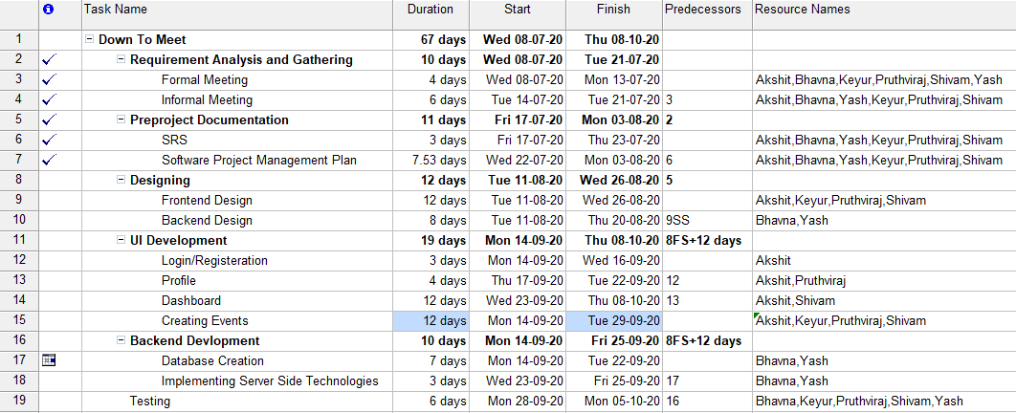

**Figure 1. Work Plan**

## 3.2.2 Schedule Allocation

The following figure shows the Gantt Chart and Network Diagram that describes the schedule allocation of the project.

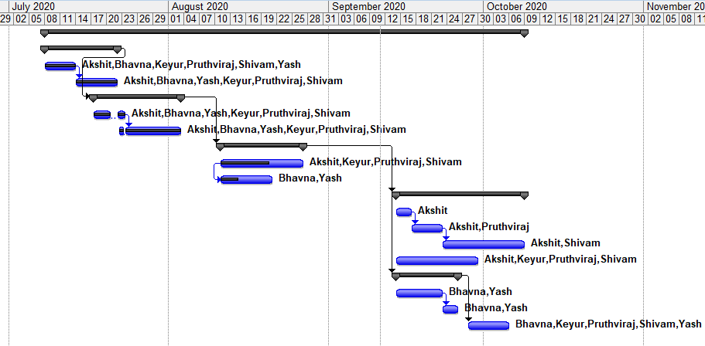

**Figure 2. Gantt Chart**

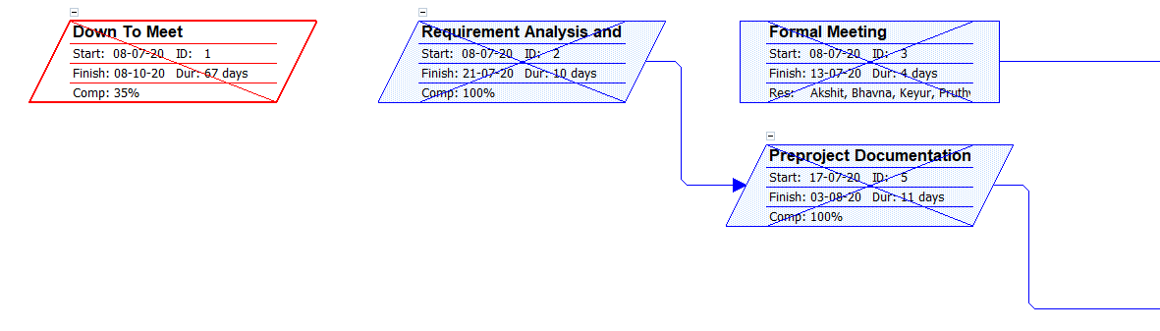

**Figure 3. Network Chart**

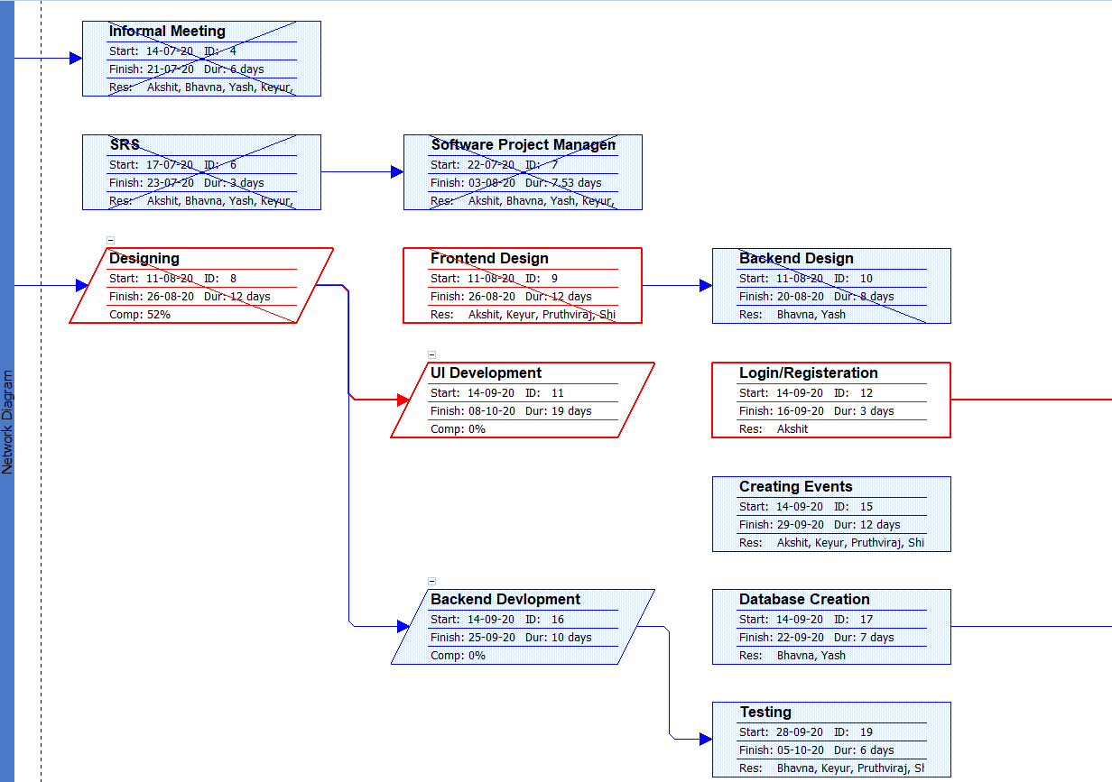

**Figure 4. Network Chart**

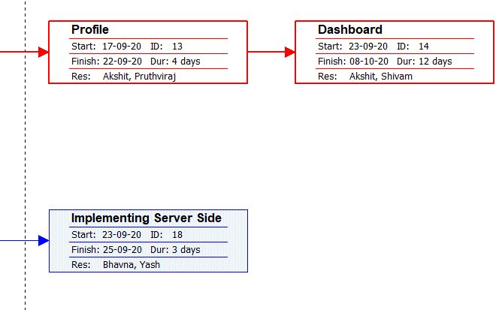

**Figure 5. Network Chart**

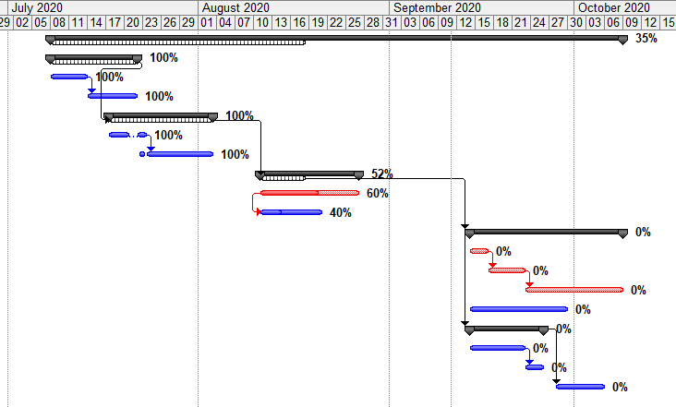

**Figure 6. Tracking Gantt Chart**

## 3.2.3 Resource Allocation

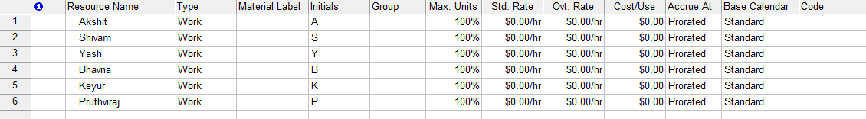

**Figure 7. Resource Allocation**